**CSE523 Machine Learning**

**Prof. Mehul Raval**

**Weekly report**

**Group number: 17**

**Group name: The Mandelbrot set**

| **Name** | **Enrolment Number** |
| --- | --- |
| Aastha Gaudani | AU2040032 |
| Khushi Patel | AU2040068 |
| Devyash Shah | AU2040152 |
| Simran Khoja | AU1910606 |

**Report**

We have continued the implementation of our model of text classification. We wanted to increase our accuracy so we have implemented multinomial naïve bayes with count vectorizer.

First as earlier we preprocessed our data, then we used feature extraction using count vectorizer and then we trained our model using MNB algorithm.

MNB (Multinomial Naïve Bayes)

Multinomial Naive Bayes algorithm is a probabilistic learning method that is mostly used in Natural Language Processing (NLP). The algorithm is based on the Bayes theorem and predicts the tag of a text such as a piece of email or newspaper article. It calculates the probability of each tag for a given sample and then gives the tag with the highest probability as output.

By implementing this new model out accuracy increased to 97 percent.

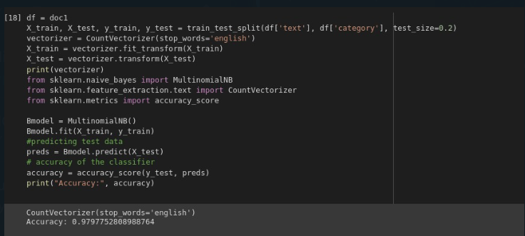

So this was our work for this week.